Variable Argument (Varargs)
The varargs allows the method to accept zero or multiple arguments. Before varargs either we use overloaded method or take an array as the method parameter but it was not considered good because it leads to the maintenance problem. If we don't know how many argument we will have to pass in the method, varargs is the better approach.

Advantage of Varargs:
We don't have to provide overloaded methods so less code.

Syntax of varargs:
The varargs uses ellipsis i.e. three dots after the data type. Syntax is as follows:
return_type method_name(data_type... variableName){}

Simple Example of Varargs in java:

class VarargsExample1{
static void display(String... values){
System.out.println("display method invoked ");
}
public static void main(String args[]){
display();//zero argument
display("my","name","is","varargs");
//four arguments
}
}

Output:
display method invoked
display method invoked

Another Program of Varargs in java:

class VarargsExample2{
static void display(String... values){
System.out.println("display method invoked ");
for(String s:values){
System.out.println(s);
}
}
public static void main(String args[]){
display();//zero argument
display("hello");//one argument
display("my","name","is","varargs");//four arguments
}
}

Output:
display method invoked
display method invoked
hello
display method invoked
my
name
is
varargs

Rules for varargs:
While using the varargs, you must follow some rules otherwise program code won't compile. The rules are as follows:
- There can be only one variable argument in the method.
- Variable argument (varargs) must be the last argument.

Examples of varargs that fails to compile:
void method(String... a, int... b){}//Compile time error
void method(int... a, String b){}//Compile time error

Example of Varargs that is the last argument in the method:

class VarargsExample3{
static void display(int num, String... values){
System.out.println("number is "+num);
for(String s:values){
System.out.println(s);
}
}
public static void main(String args[]){
display(500,"hello");//one argument
display(1000,"my","name","is","varargs");//four arguments
}
}
Output:
number is 500
hello
number is 1000
my
name
is
varargs

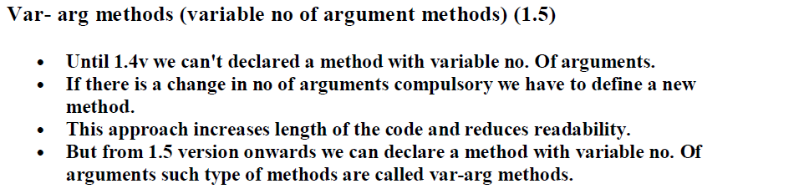

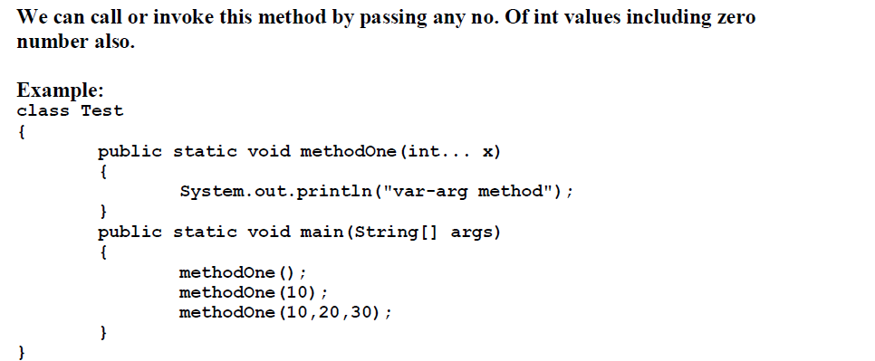
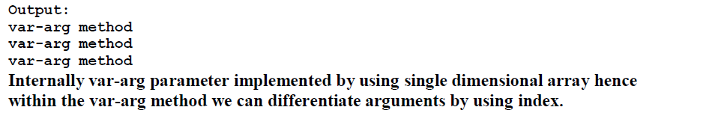
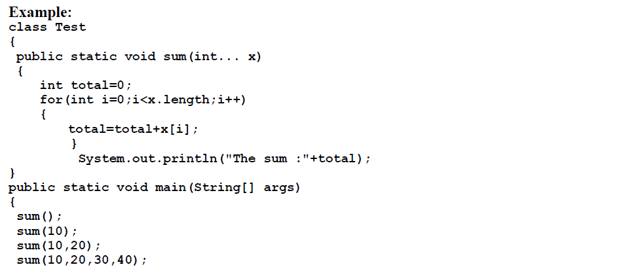
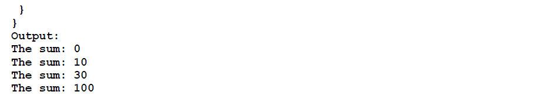
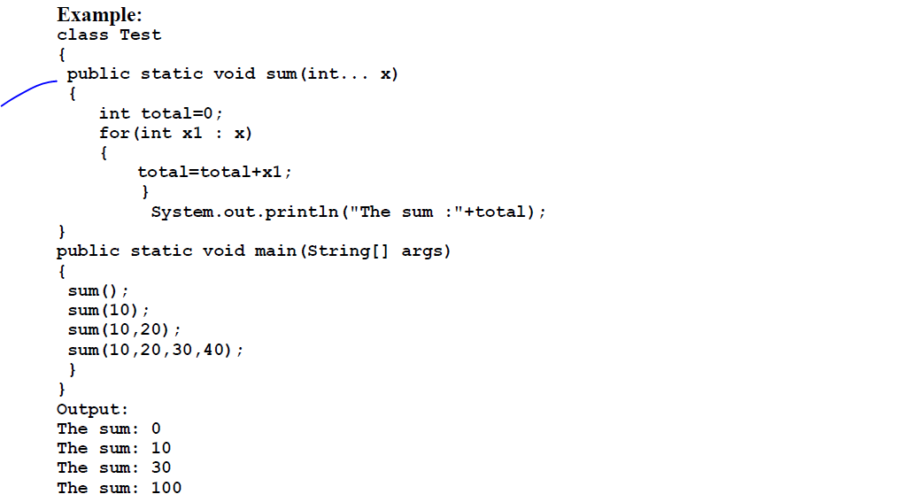
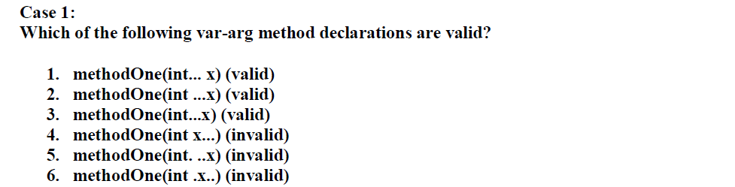
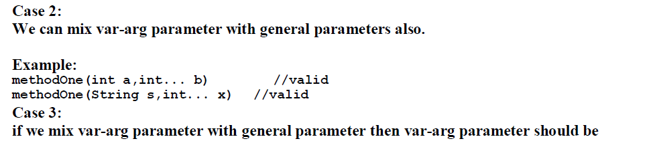
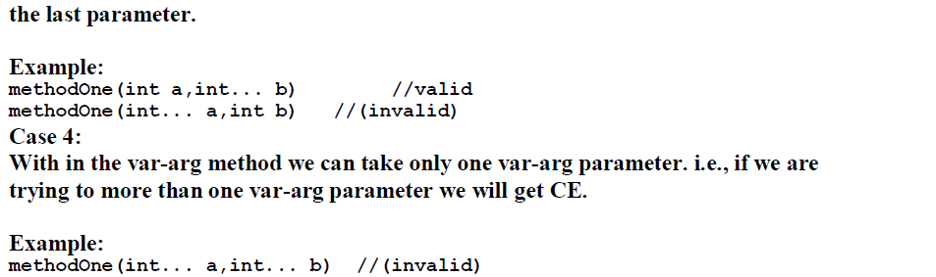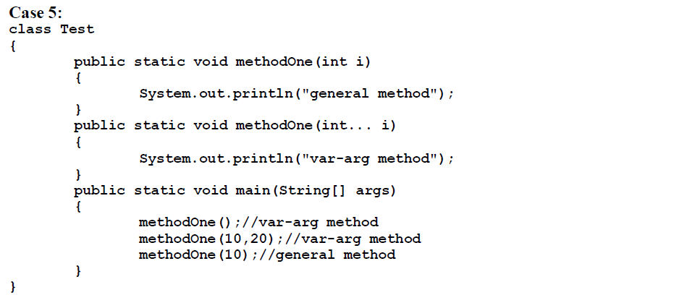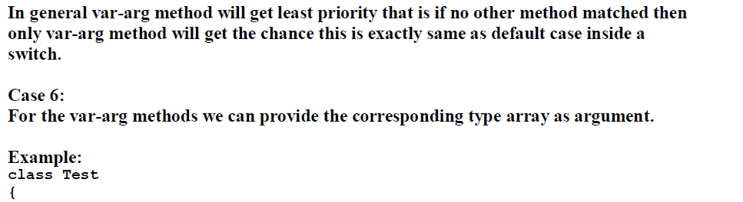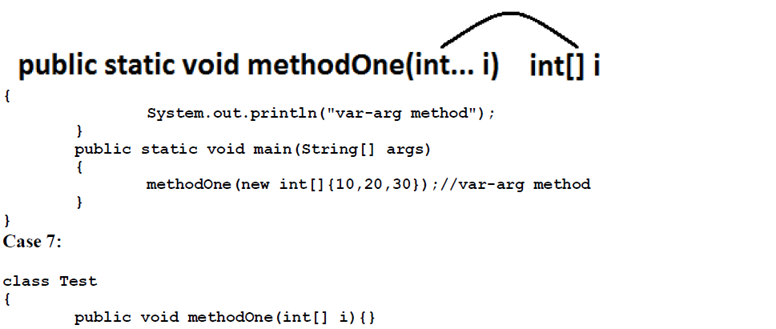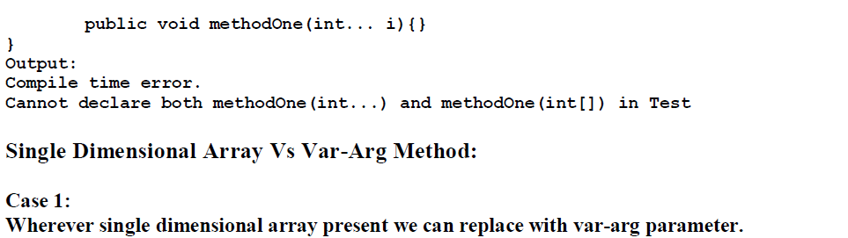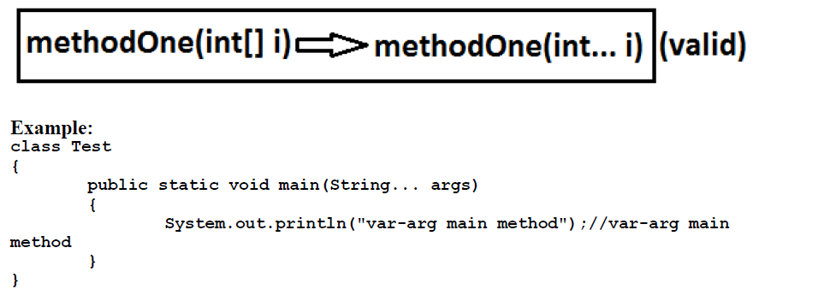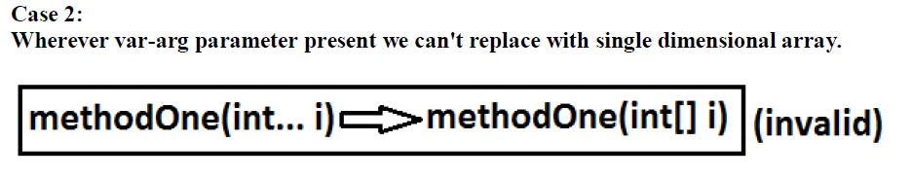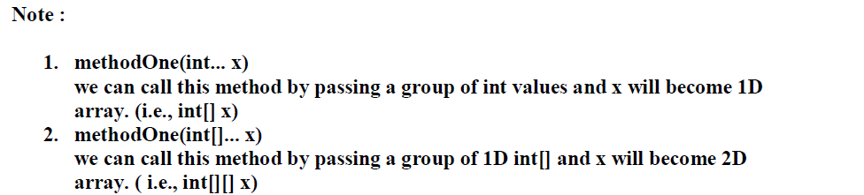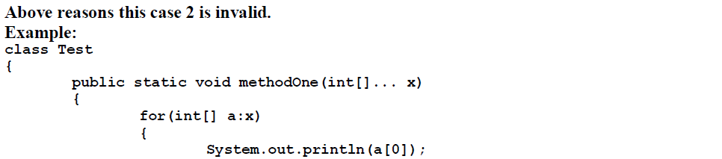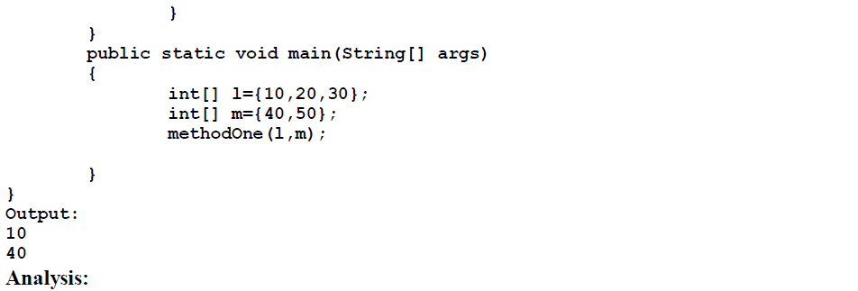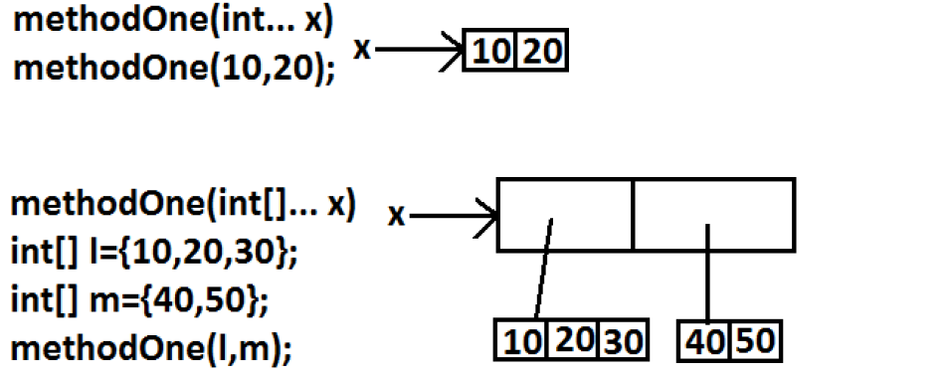

Problem Description:
How to use variable arguments as an input when dealing with method overloading?

Solution:
This example displays how to overload methods which have variable arguments as an input.
public class Main {
static void vaTest(int ... no) {
System.out.print("vaTest(int ...): " + "Number of args: " + no.length +" Contents: ");
for(int n : no)
System.out.print(n + " ");
System.out.println();
}
static void vaTest(boolean ... bl) {
System.out.print("vaTest(boolean ...) " +Number of args: " + bl.length + " Contents: ");
for(boolean b : bl)
System.out.print(b + " ");
System.out.println();
}
static void vaTest(String msg, int ... no) {
System.out.print("vaTest(String, int ...): " +msg +"no. of arguments: "+ no.length +" Contents: ");
for(int n : no)
System.out.print(n + " ");
System.out.println();
}
public static void main(String args[]){
vaTest(1, 2, 3);
vaTest("Testing: ", 10, 20);
vaTest(true, false, false);
}
}

Result:
The above code sample will produce the following result.
vaTest(int ...): Number of args: 3 Contents: 1 2 3
vaTest(String, int ...): Testing: no. of arguments: 2
Contents: 10 20
vaTest(boolean ...) Number of args: 3 Contents:
true false false

Problem Description:
How to make a method take variable length argument as an input?

Solution:
This example creates sumvarargs() method which takes variable no of int numbers as an argument and returns the sum of these arguments as an output.
public class Main {
static int sumvarargs(int... intArrays){
int sum, i; sum=0;
for(i=0; i< intArrays.length; i++) {
sum += intArrays[i];
}
return(sum);
}
public static void main(String args[]){
int sum=0;
sum = sumvarargs(new int[]{10,12,33});
System.out.println("The sum of the numbers is: " + sum);
}
}

Result:
The above code sample will produce the following result.
The sum of the numbers is: 55

Note:

Normal Method
public void MyMeth(int a,int b){....}

VarArg Method
public void MyMeth(int... a) {....}

Explanation
The normal method above takes no more than 2 parameters of int type.
The varargs method takes as much number of parameters as you give of int type only*
As discussed earlier, the use of varargs is this one. You cannot write as many as parameters for a method and also if you do, you must ensure that values to every parameter are sent when you make the method call. This is a drawback of the normal methods but not for the varargs method not only in Java but in any programming language.
Not only for primitive types, varargs in java is applicable for classes also. Simply, applicable for all kinds of parameters.

How it works?
In the above varargs method, parameter acts as an int array with a reference name a. To check this, you can call the length property of the arrays and that works.
Varargs is not just a simple concept in Java, it is highly important at critical times for the developers. This tutorial demonstrates the main part necessary for developers to fire. You'll have to note that not only in Java but C/C++ do support varargs. This feature in Java is implemented from Java 5 (Java 1.5) version.

Varargs for Integer in Java

An example on using single variable arguments for int in Java.
class VarArgsIntExample{
public static void main(String args[]){
sum(1,2,4,5);
sum(1,2);
sum(a);
}
public static void sum(int... a){
int sum=0;
for(int i=0;i<a.length;i++){
sum+=a[i];
}
System.out.println("The sum is "+sum);
}
}

Output
The sum is 12
The sum is 3

Explanation
The three dots (...) after the data type in the method indicate that variable argument is defined. The type of the varargs is int and the name given to it is a. The var a acts like the reference of an int[]. Proof for this is in the for loop statement a.length where length is a property of the arrays. So by this, a is an array and that's confirmed.

You'll have to note that the way we call the method sum(int... a) in the main() is not like we're giving an int array to it. It is like passing as many numbers of arguments which should be summed. You can also pass an array to it instead of those many parameters. But if you declare sum() as sum(int[] a) instead of sum(int... a) that could not be possible. Because, the parameter for the sum(int[] a) is an array and of course, that too a single parameter.

Varargs for String in Java

The following example illustrates Varargs for String using a simple static method in for easy understands.
class VarArgsExample{
public static void main(String args[])
concat("java","-","demos",".","blogspot",".","com");
concat("Gowtham ","Gutha");
}
public static void concat(String... s){
String temp="";
for(int i=0;i<s.length;i++){
temp+=s[i];
}
System.out.println(temp);
}
}

Output
java-demos.blogspot.com
Gowtham Gutha

Explanation
Not only for primitive types like int varargs in Java is applicable for wrapper classes like String also. I'd just like to say that not just for wrapper classes, again varargs is applicable for any class. The logic is something used for concatenating more than 2 strings. This is the way of using varargs for String class, in a similar way for other classes too.

Varargs with Multiple Parameters

The following example illustrates varargs with multiple parameters.
class MultipleParam{
public static void main(String args[]) {
sum("1+2+4+5=",1,2,4,5);
sum("1+2=",1,2);
int a[]={1,8151191,817};
sum("1+8151191+817=",a);
}
public static void sum(String s,int... a) {
int sum=0;
for(int i=0;i<a.length;i++) {
sum+=a[i];
}
System.out.println(s+sum);
}
}

Output
1+2+4+5=12
1+2=3
1+8151191+817=8152009
sum(String s,int... a): When declaring vararg method with multiple parameters the vararg parameter must succeed after normal parameters.

this():

this() is used to invoke and access the 0 parametrized constructor of the same class inside another constructor.

this(...)

this(...) is used to invoke and access the parameterized constructor of the same class inside another constructor.

//program to demo on this(), this(...)

class Demo{
Demo(){
this(10);
System.out.println("this is 0 parameterized constructor");
}
Demo(int x){
System.out.println("this is 1 parameterized constructor");
}
Demo(int x,int y){
this();
System.out.println("this is 2 parameterized constructor");
}
}
class ThisDemo2{
public static void main(String args[]){
Demo d = new Demo(10,20);
}
}

o/p:

this is 1 parameterized constructor
this is 0 parameterized constructor
this is 2 parameterized constructor

Rules
1. Calling this() or this(...) must be the first statements in the constructor.
2. Calling this() or this(...) must not be inside the regular method
3. We can call this() or this(...) at most 1 time
4. Calling this() or this(...) must not provide a recursive constructor invocation

super keyword

super keyword refer to parent class instance or object so that we can access
instance and static members of the Parent class with in the child class.

Writing super keyword is sometimes mandatory, sometimes optional
If there is no confusion between instance variables of Parent class and instance variables of Child class then writing super keyword is optional. But In this case compiler will write this keyword and refer to instance variable of Child class.

But if there is confusion between instance variables of Parent class and instance variables of Child class then writing super keyword is mandatory. Even In this case compiler will write this keyword only and refer to instance variable of Child class. But if we want to refer to instance variable of Parent class we have to write super keyword

//wap to demo on super keyword
class Parent{
int a=10;
int b=20;
void show1(){
System.out.println("Parent class show1() method");
}
void show2(){
System.out.println("Parent class show2() method");
}
}
class Child extends Parent{
int a=30;
int c=40;
void show1(){
System.out.println("Child class show1() method");
}
void show3(){
System.out.println("Child class show3() method");
}
void show4(){
int a=50;
int d=60;
System.out.println(super.a);
//super is mandatory(Parent class a val)
System.out.println(this.a);
//this is mandatory(Child class a value)
System.out.println(a);
//local variable a value
System.out.println(b);
//super or this is optional(Parent class b value)
System.out.println(c);
//this is optional (Child class c value)
System.out.println(d);
// local variable d value
super.show1();
//super is mandatory (calls Parent class show1())
this.show1();
// this is optional(calls Child class show1())
show2();
// super or this optional (calls Parent class show2())
this.show3();
// this optional (calls Child class show3())
}
}
class SuperDemo1{
public static void main(String args[]){
Child c= new Child();
c.show4();
}
}

Note:
- A super keyword can access both instance and static members of the Parent class with in child class instance methods, but we can not use super keyword within any static method of child class.
- We don't write any this keyword or super keyword compiler always write this keyword only but not any super keyword
- super keyword in child class always point to the variables or methods of its immediate parent class.
Eg:
class Cone{
int a=10;
}
class Ctwo extends Cone{
int a=20;
}
class Cthree extends Ctwo{
int a=30;
void show(){
System.out.println(super.a); //20
Cone c = new Cone();
System.out.println(c.a);
}
}
class SuperDemo2{
public static void main(String ars[]){
Cthree c = new Cthree();
c.show();
}
}

super()

This super() is used to call the parent class 0 parametrized constructor in side the constructors of Child class.

super(...)

This super(...) is used to call the parent class parameterized contructor in side the constructors of Child class.

//wap to demo on super() or super(...)
class Parent{
Parent(){
System.out.println("Parent class 0 parameterized constructor");
}
Parent(int x){
this();
t.println("Parent class 1 parameterized constructor");
}
}
class Child extends Parent{
Child(){
this(10,20);
System.out.println("Child class 0 parameterized constructor");
}
Child(int x){
this();
System.out.println("Child class 1 parameterized constructor");
}
Child(int x,int y){
super(10);
System.out.println("Child class 2 parameterized constructor");
}
}
class SuperDemo3{
public static void main(String ars[]){
Child c = new Child(10);
}
}

Note:

Inside the constructor if we don't write either this() or super() then compiler will automatically writes super() always. so that every child class constructor will invoke its parent class constructor by default.

Rules

- Calling super() or super(...) or this() or this(...) must be the first statement in the constructor

- Calling super() or super(...) or this() or this(...) must not be in side the regular method

- We can call super() or super(...) or this() or this(...) at most 1 time

- Calling super() or super(...) or this() or this(...) must not provide a recursive constructor invocation

ellipsis (...) operator

ellipsis (...) operator introduced in java 1.5 version which is used to create method with variable number of arguments

ellipsis operator internally maintained just like an array.

ellipsis operator used in only 1 location in entire java that is while writing the parameters of the method.

// wap to demo on ellipsis (...) operator

class Demo{
void sum(int... a){
//System.out.println("No.of Parameters="+a.length);
int c=0;
for(int i=0;i<a.length;i++){
c = c + a[i];
}
System.out.println("sum="+c);
}
public static void main(String args[]){
Demo d = new Demo();
d.sum(10);
d.sum(10,20);
d.sum(10,20,30);
d.sum(10,20,30,450);
d.sum(10,13,60,70,70,60,20);
d.sum(new int[]{21,34,56});//ellipsis operatator takes array
d.sum(new int[]{21,34,56,67,78,78,89});
}
}

Note:

In a method/constructor we can also write normal parameters along with parameters which are declared using ellipsis operator but in this case first we have to write normal parameters and followed by parameters which are declared using ellipsis operator.

void sum(int... ar,int x){ X-invalid
}
void sum(int x,int... ar){ valid
}

We can also write our main() method using ellipsis (...) operator

public static void main(String... args){
}

What is the diff between (int... args) and (int[] args)

In a method if we use ellipsis (...) operator we can pass any number of arguments but if we use array as parameter then we have to pass only 1 argument that is an array which may contain any number of values.

Eg:

class Demo{
void add(int... a){
int c=0;
for(int i=0;i<a.length;i++){
c = c + a[i];
}
System.out.println("sum="+c);
}
void mul(int[] a){
int c=1;
for(int i=0;i<a.length;i++){
c = c * a[i];
}
System.out.println("mul="+c);
}
public static void main(String args[]){
Demo d = new Demo();
d.add(10);
d.add(10,20,30);
d.add(new int[]{10,20,30,40});
d.mul(new int[]{10,20,30});
d.mul(new int[]{10,20,30,40,50,40});
//d.mul(10,20,30); -invalid because mul() take only 1 argument
}
}

Note:

We cannot overload 2 methods which takes array as parameter and second one takes ellipsis operator as parameter.

void add(int... a){ X-invalid
}

void add(int[] a){
}
Note:
Another issue in using varargs is knowing which method will be called if there appears to be competing signatures. In the following class, WhichOne, there are three constructors. The first constructor takes a vararg argument, the second takes two int arguments, and the third takes two Integer arguments:
public class WhichOne {
WhichOne(Integer... size) {
System.out.println("Var Args version.");
}
WhichOne(int i, int j) {
System.out.println("Version with int args.");
}
WhichOne(Integer i, Integer j) {
System.out.println("Version with Integer args.");
}
public static void main(String[] args) {
System.out.println("Call w/ two arg:2,3");
new WhichOne(2, 3);
System.out.println("Call w/ Integer two arg:2,3");
new WhichOne(new Integer(2), new Integer(3));
}
}

Run WhichOne and you will see the following output:
Call w/ two arg:2,3
Version with int args.
Call w/ Integer two arg: 2,3
Version with Integer args.
Even with the varargs version of the constructor, the most specifically-matching constructor is called. Eliminate the second and third constructors so that WhichOne looks like the following:
public class WhichOne {
WhichOne(Integer... size) {
System.out.println("Var Args version.");
}
public static void main(String[] args) {
System.out.println("Call w/ two arg:2,3");
new WhichOne(2, 3);
System.out.println("Call w/ Integer two arg:2,3");
new WhichOne(new Integer(2), new Integer(3));
}
}

Return WhichOne. You should see the following output:
Call w/ two arg:2,3
Var Args version.
Call w/ Integer two arg: 2,3
Var Args version.
In the absence of the more specific constructors, the varargs version is called by both new WhichOne(2,3) and by new WhichOne(new Integer(2), new Integer(3)). It is important in constructing an API to make clear to the client how to call the desired method. So the lesson here is avoid using varargs on overloaded methods.
To reiterate, the advantage of using varargs is that as a client of an API, you are free to call a method using a sequence of instances of an object of the specified type or an array. You have the freedom to make the call using any number of instances of that type. There are also dangers in using varargs. You might want to avoid providing methods that use varargs when it is important to specify the number of entries or to prevent autoboxing.
Why is varargs always the last parameter in a method signature?

The main reason is because it would be potentially ambiguous otherwise....
For example, how could the compiler tell whether arguments are varargs or separate named arguments in a long list of arguments with multiple varargs?
Imagine a method signature like:
printNames(String... girls, String... boys);
If you do printNames("Lucy", "Jo", "Paul") is Jo a boy or a girl?
As another example of ambiguity, having varargs earlier in the argument list could cause problems when there are overloaded methods. For example:
printFruit(String... apples, String orange);
printFruit(String... apples, String grapefruit, String orange);
How can the compiler tell whether the second-to-last argument is a grapefruit or an additional apple?
Note that this isn't unique to Java, most languages that support varargs only allow then to be at the end of the argument list for the same reason.

Variable arguments before Java 1.5
Prior to Java 1.5 Java programmer mainly have two choices to :
1. Either overloads the method.
2. Or can take an array or Collection and pass the no of argument wrapped in array or Collection like List, Set or Map.

But the problem with this is to if he is overloading the method and he don’t know about how many arguments he has to handle how many method will be created in the code i.e. the code will become clumsy or if he has not created sufficient method then again the codes need to be modified and complied so it’s become repetitive task which is not a good programming practice and requires more maintenance .Now we can go for array also but why not we give this task to Java for creating an array and store the element in to that array to internally handle and let make programmer free of this, I guess with this thought varargs comes into existence.
varargs or variable arguments makes it possible for us to call one method with variable number of argument; means define only one method and call that method with zero or more than zero argument.

Important points related to variable argument or varargs methods:

1) Every call to varargs method requires an anonymous array to be created and initialized which could affect performance in time critical application. There is an alternative of varargs method to achieve better performance. Suppose you have a variable argument method sum(int... num) and it’s called with 2 parameters on 90% of time. In order to avoid array creation and initialization you can use method overloading in Java to provide two versions of sum() which accept int instead of varargs. Here is an example of better performance alternative of varargs for 90% of time

public int sum(int a);
public int sum(int a, int b);
public int sum(int... num);

Now 90% of time method without varargs will be invoked and 10% of time method with variable argument will be invoked.

2) An example of variable argument method from JDK is Arrays.asList(T... args) which was used to convert array to ArrayList before JDK 1.5 but retrofitted to support variable argument in JDK 1.5. Now you can also invoke this method by just passing as many Strings or object as you want and creating a List representation on the fly. It’s one of the quickest way to convert Strings into List e.g.

List listOfString = Arrays.asList("Red", "White", "Blue");
3) Another example of varargs methods are in java.lang.reflect package. Reflection uses lot of variable argument method to call overloaded method dynamically. Method class used variable argument to get correct version of overloaded method. Method.getMethod(String name, Class... parameterTypes) uses last argument as parameter type which is a variable argument and can accept any number of parameters. This is used to invoke method by name using reflection.

4) If you are working on a legacy project which is not running on Java 1.5 or higher, you can still implement variable argument methods by using Anonymous array or Collection classes like ArrayList or HashSet. Both array or Collection classes can wrap number of argument into one. Using Collection framework also has an added advantage in terms of rich API e.g. meaningful toString() method, iteration support etc

How Variable Argument Works?
When we invoke a method with variable arguments, java compiler matches the arguments from left to right and once it reaches to the last varargs parameter, it creates an array of the remaining arguments and pass it to the method. In fact varargs parameter behaves like an array of the specified type
//method with variable arguments
public static int sum(int i, int...js ){
int sum = i;
for(int x : js){
sum+=x;
}
return sum;
}
//method with same implementation as sum with array as argument
public static int sumArray(int i, int[] js ){
int sum = i;
for(int x : js){
sum+=x;
}
return sum;
}
If you will look at both sum and sumArray methods, you will see that the implementation body is exactly same. So we should use varargs when API offers them, for example java.io.PrintStream.printf() method but we should not take it as a replacement for array.
Why we should not overload varargs method?

package com.journaldev.misc;
public class VarargsExample {
public static void main(String[] args) {
System.out.println(sum(1));
System.out.println(sum(1,2));
//compiler error, ambiguous method
}
public static int sum(int i, int...js ){
System.out.println("sum1 called");
int sum = i;
for(int x : js){
sum+=x;
}
return sum;
}
public static int sum(int i, int k, Object...js ){
System.out.println("sum2 called");
int sum = i+k;
for(Object x : js){
sum+=1;
}
return sum;
}

}
In above example, you will notice that compiler will not complain when we overload methods with varargs, but as you can see that when we try to use it, compiler gets confused which method to use when mapping the second argument. If there is only one argument, compiler is smart to use first method because it can work with minimum one argument but second method needs at least two arguments.

